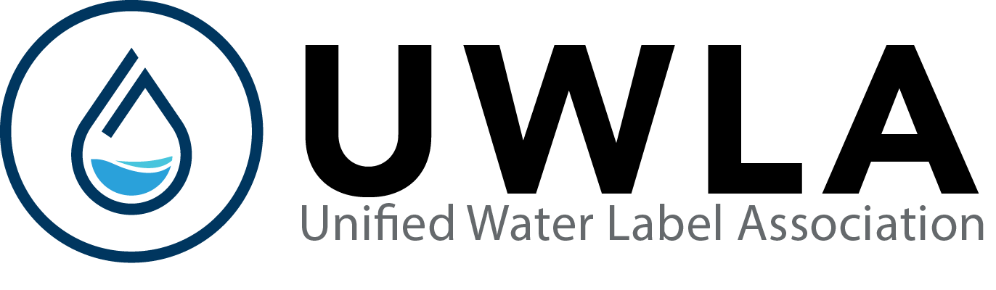

TEST HOUSE APPLICATION FOR REGISTRATION
Scheme
Unified Water Label
Rue Belliard 12, 1040
Brussels
Belgium

Telephone: 07980 600446
Email: schememanager@uwla.eu
Web: www.uwla.eu

Date of Application: ___________________________________________________________________________________

Section 1: Company Details

- FULL Company Name & Address:

____________________________________________________________________________________________________

____________________________________________________________________________________________________

Country Postcode/Zipcode: Tel no: __________________________________ Fax no: ______________________________

Web address: ________________________________________________________________________________________

- Registered Company Number and VAT Number:

____________________________________________________________________________________________________

- Accreditation Body:

____________________________________________________________________________________________________

Accreditation Number: _________________________________________________________________________________

All test laboratories shall be accredited to EN ISO 17025 for each relevant area of interest.

- Full name person authorised for process of registration:

Mr/Ms: ________________________________________________________________________________________

Telephone Number (Include Country dialling code): ____________________

Email: ______________________________________________________________

In order for a test laboratory to cover all potential tests and/or audit requirements they shall cover the following standards in the scope of their accreditation:

EN 200: Sanitary Tapware - Single taps and combination taps for water supply systems of type 1 and type 2 - General technical specifications;

EN 997: WC Pans and WC Suites with integral trap;

EN 1111: Sanitary Tapware - Thermostatic mixing valves (PN 10). General technical specification;

EN 1113: Sanitary Tapware - water supply systems of type 1 and type 2 - General technical specifications;

EN 1287: Sanitary Tapware - Low pressure thermostatic mixing valves. General technical specifications;

EN 14055: WC and Urinal Flushing Cisterns;

Section 2: Company Statement (Company means the qualifying business as identified in Section 1)

I/We hereby apply to the Unified Water Label, for registration as an accredited Test House.

I/We have read and understood the information contained in the rules and regulations of the Scheme issued by the Unified Water Label. I/We certify that all statements made and information given in this application are true to the best of our knowledge and belief.

Signature of authorised personnel (must be the same as section 3) ______________________________________________

Print name and title of signatory: _________________________________________/________________________________________

Section 3: Verification of Accreditation:

Verification of the suitable accreditation and scopes are to be forwarded and updated on a regular basis to the Unified Water Label.

All documents submitted together with this registration are deemed to be the property of the Unified Water Label.

Payment and Verification must be received with the Test House Application for Registration.

For Office use

Received on:

Test House Registration Number:

ILAC Recognition: Yes/No

Issue Date: April 2021

